



Original Style High Quality

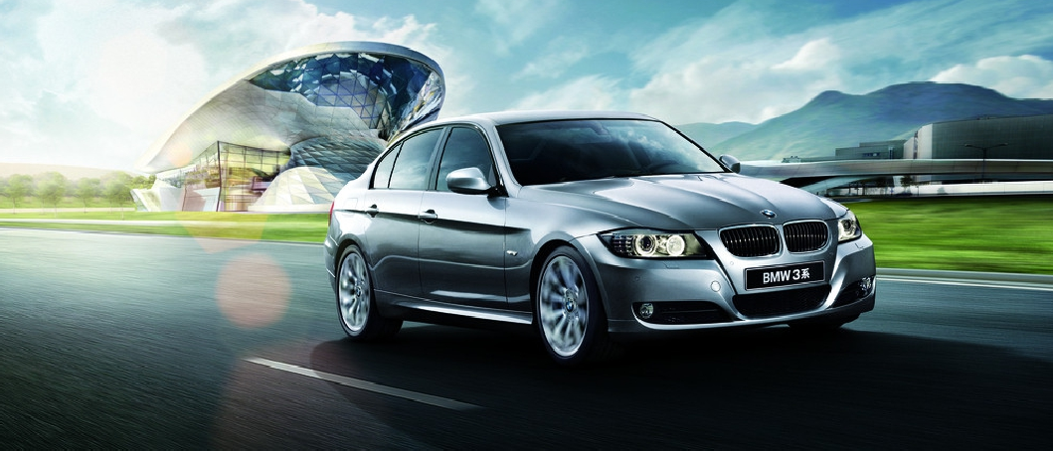**Installation Instructions of BMW 3 Series(E90) 2006-2011 [10.25"]**

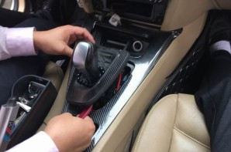

7.Lever the gears cover

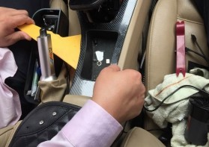

8.Lever the plastic panel on the left

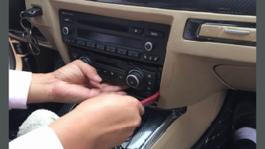

3.Pull out the air conditioning panel



4.Remove the wires

in-car navigation in-car navigation

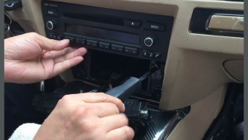

5.Take off two screws

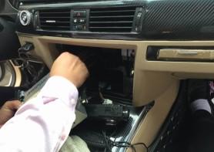

6.Take off the head unit power cable

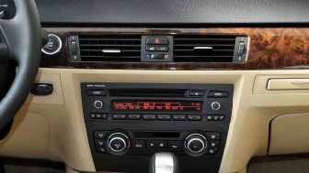

1.Before installation

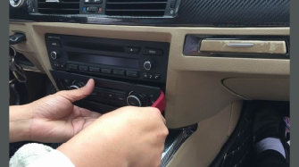

2.Pull out the air conditioning decorative panel



**BMW 3 Series(E90) 2006-2011 [10.25"]**



**BMW 3 Series(E90) 2006-2011 [10.25"]**

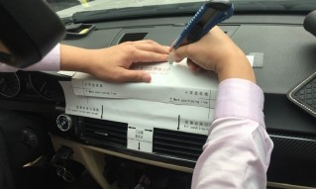

16.Cut hole according to the red lines, keep the paper stay still

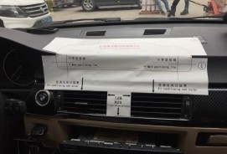

15.Paste the model paper on the dashboard according to the corresponding position

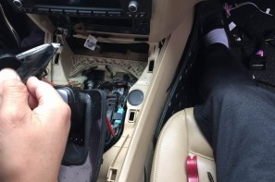

11.Remove the cigarette lighter wire

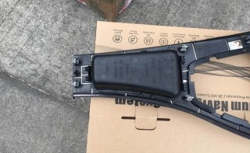

12.Remove the decorative cover

in-car navigation in-car navigation

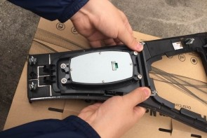

13.Install the new special mouse

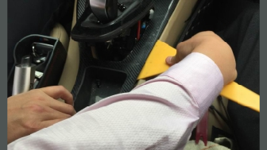

9.Lever the plastic panel on the right

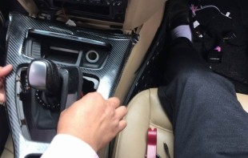

10.Remove the plastic panel

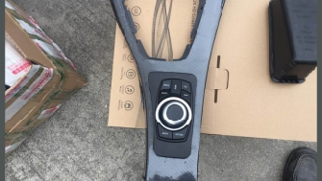

14.After installation of mouse



**BMW 3 Series(E90) 2006-2011 [10.25"]**



**BMW 3 Series(E90) 2006-2011 [10.25"]**

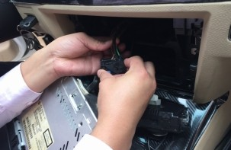

19.Pull out the car optical fiber connector, then to new power cable

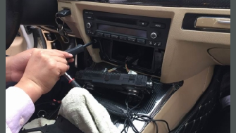

20.Fix the 2 screws

in-car navigation in-car navigation

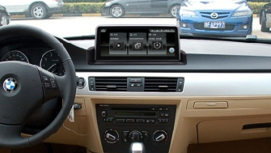

21.After installation

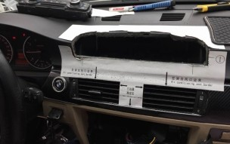

17.Then remove the model paper after cutting is finished

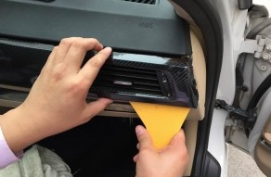

18.Pull out the vent panel, then install

the head unit



**BMW 3 Series(E90) 2006-2011 [10.25"]**



**BMW 3 Series(E90) 2006-2011 [10.25"]**